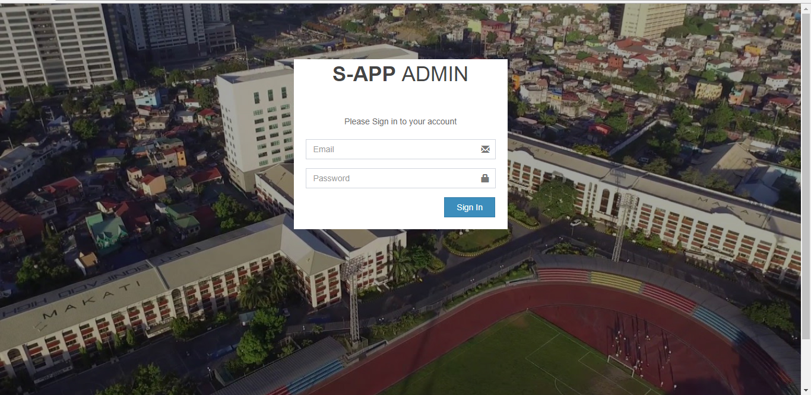

Login form for both school admin and department admin

-database table used : tbladmins (sappdb)

-if the admin is login a php function is called insert_log() .. will save the time when the admin is login

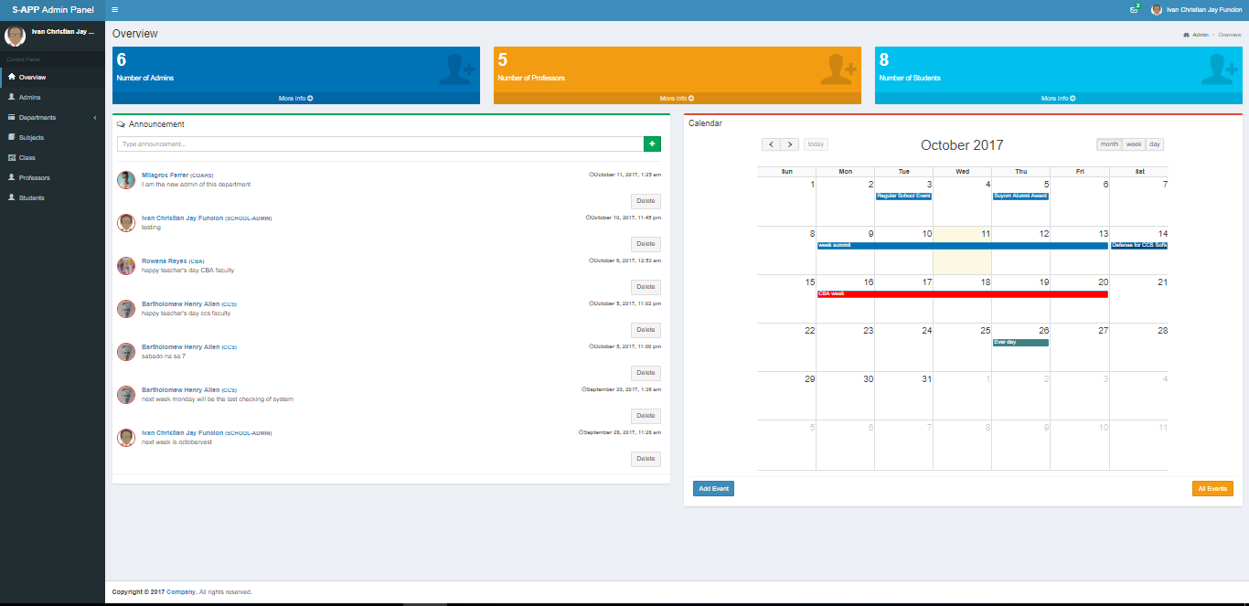

Index of the admin…. Overview panel

-after the admin successfully login , the admin will be redirect to the overview index page of the admin

-index page shows the total number of admins, professors and students

- also has a calendar in which the admin can add an event(adding of event can be a single day or multiple day)

- admin ca also view all scheduled event by clicking the all event button

-also we have an announcement panel in which the admin can post an announcement. The school admin has the capability to delete all announcement while in department admin, Only the announcement from their department can be deleted.

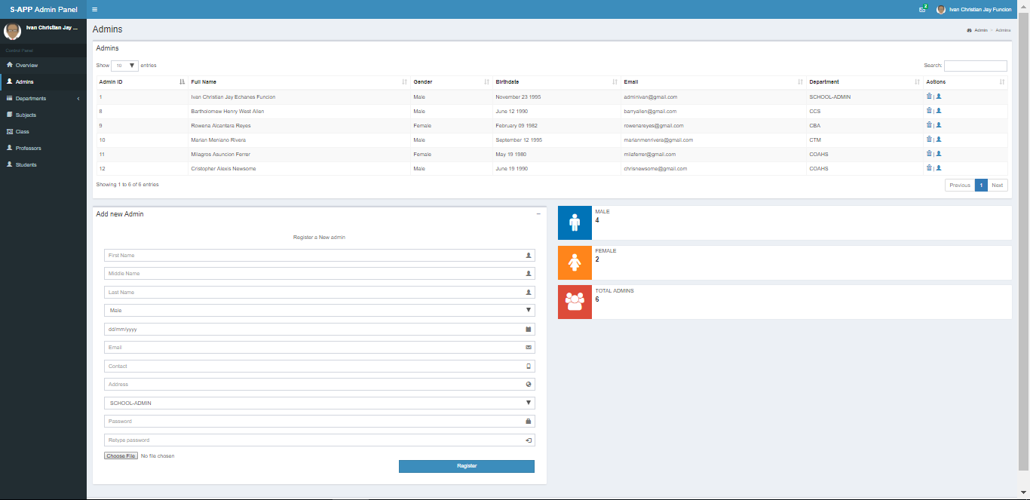

Next is the admins page or panel

In here you can see the list of admins and also their assigned department

You can also see the total number of admins

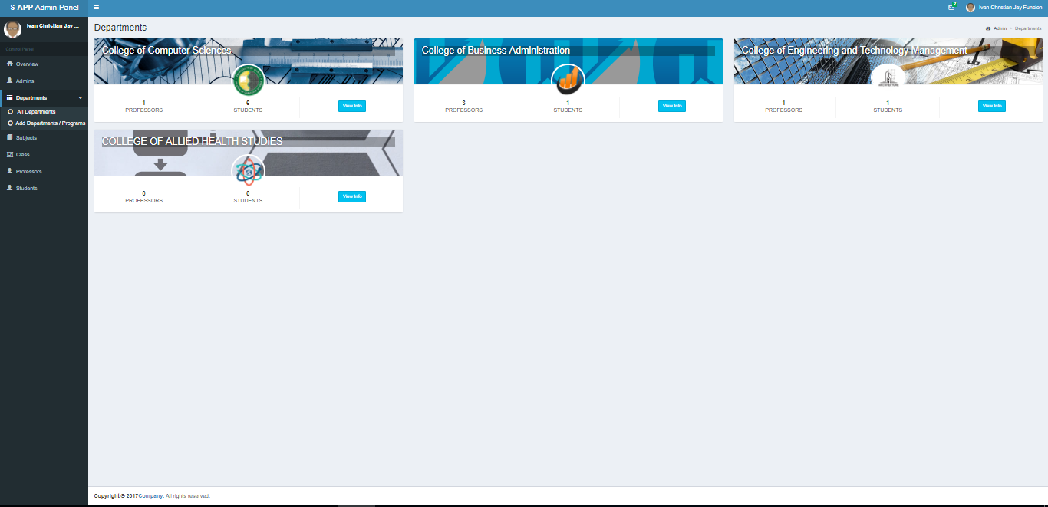You can also add admin in here

Next is the departments… you can see the list of department in the school and you can also view the information of that specific department

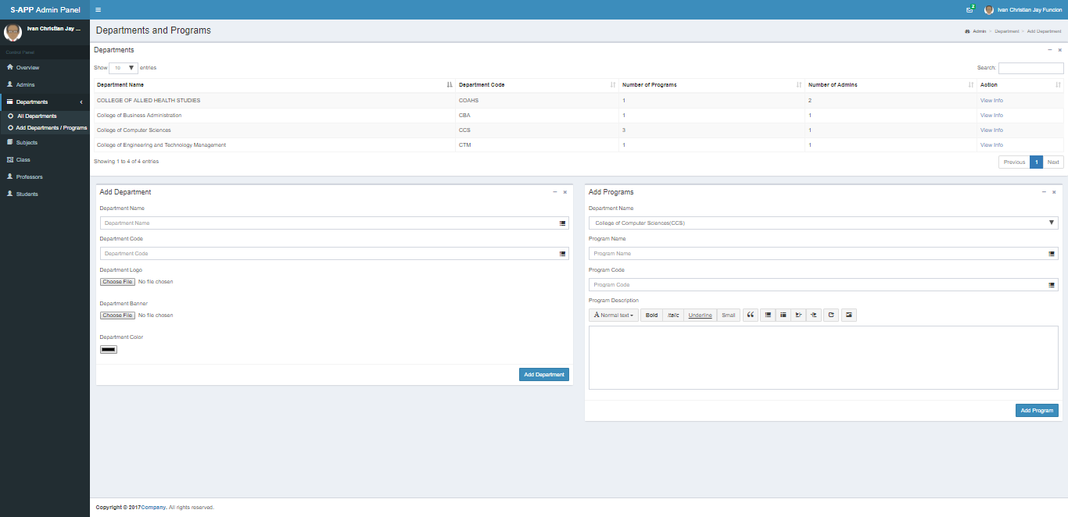

Under the department tab is you can also add another department and add a program for that department us well

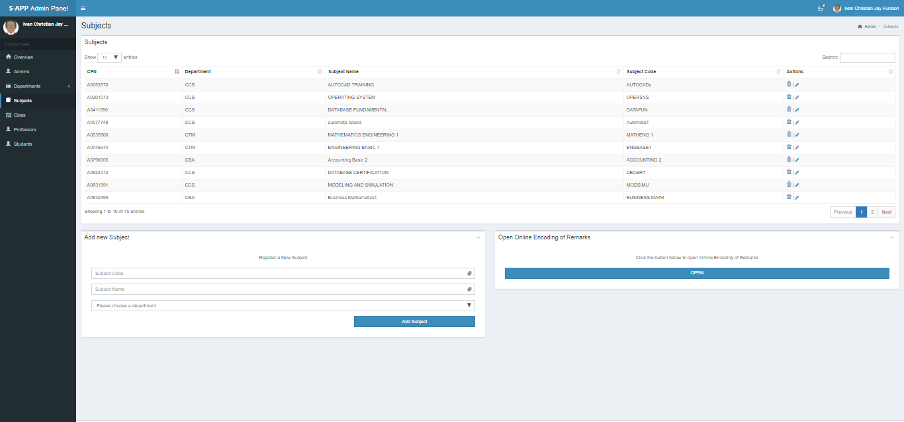

Next is the subject panel in which you can see all the list of subjects and their departments.

* You can also add a new subject In here
* Can edit the subjects name

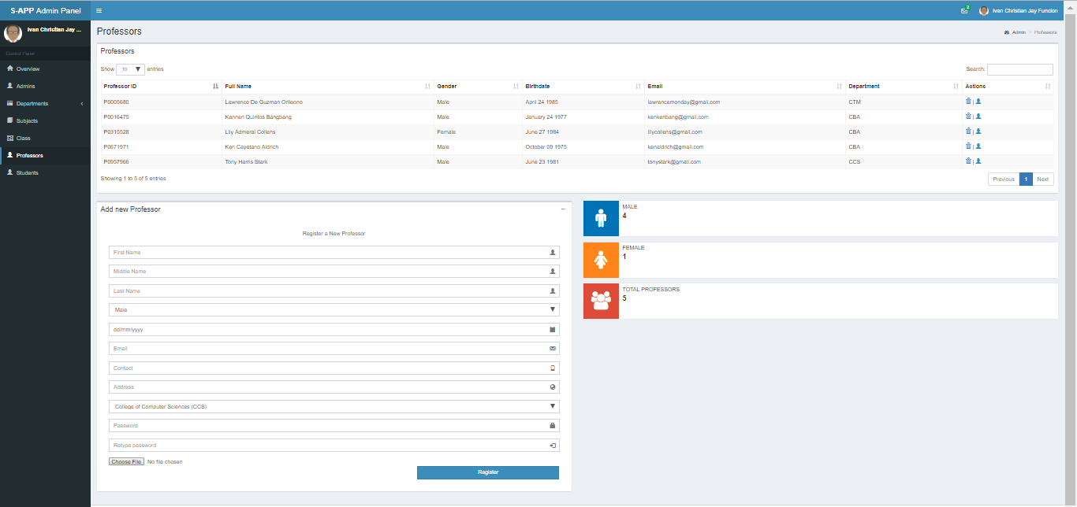

The professor panel shows the total number of professor,

* Can also add professor and assigned a department for her/him

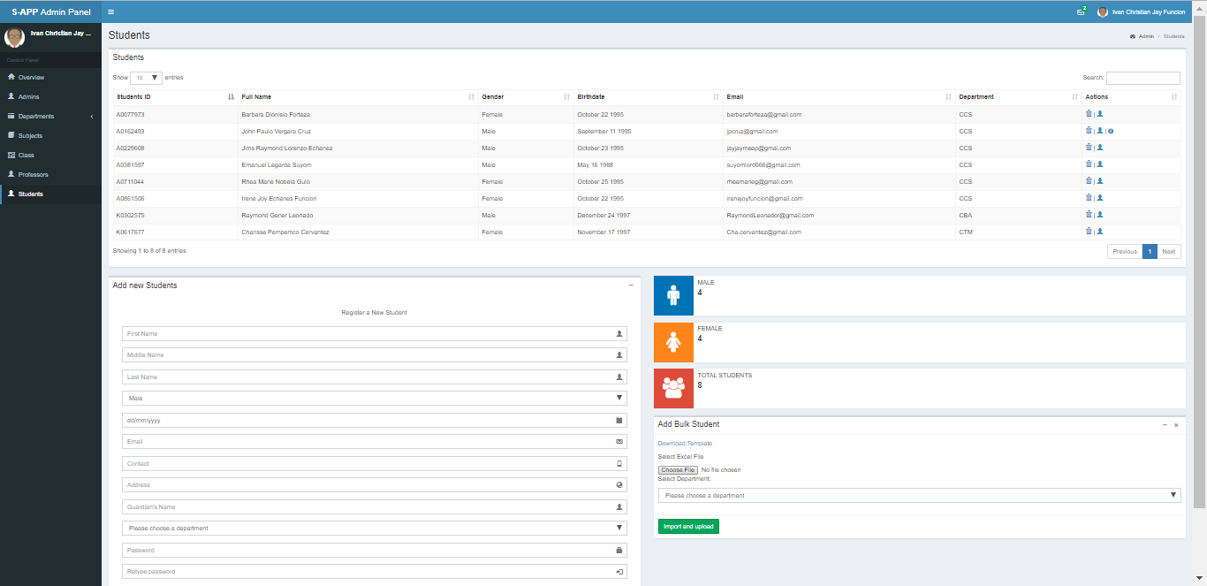

Shows the list of student in the system with their department

* Number of student
* Add student bulk or single
* Number of students male , female

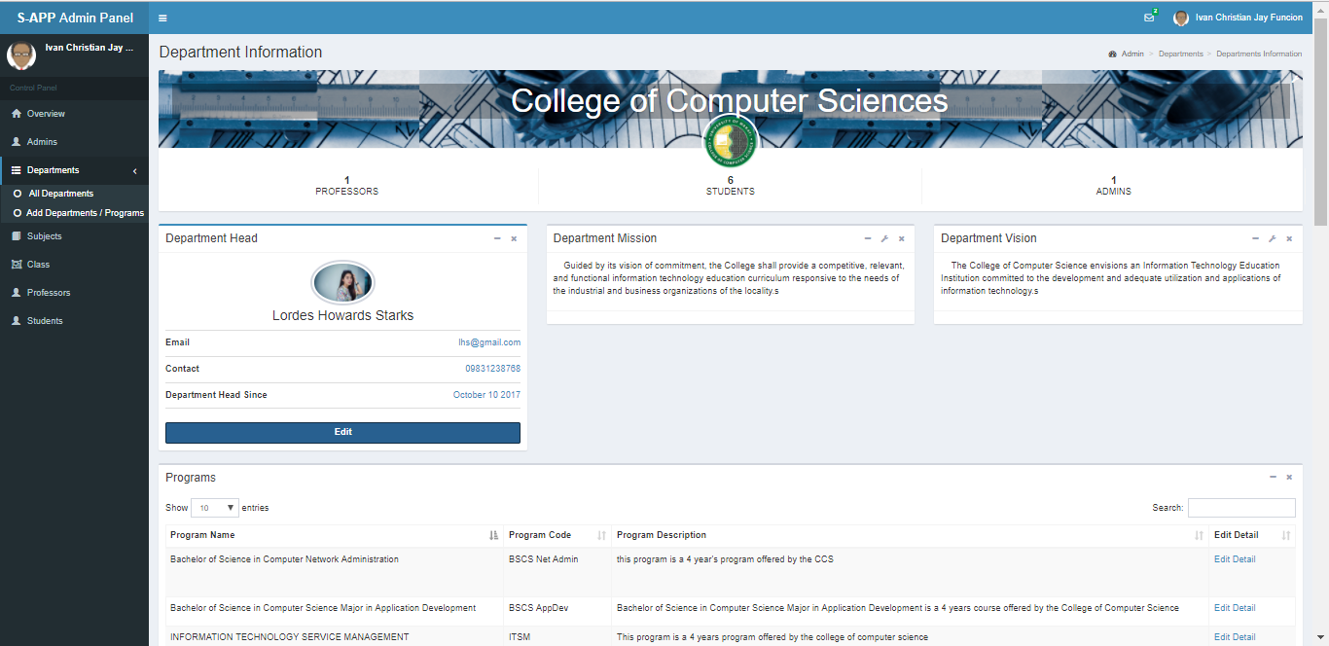

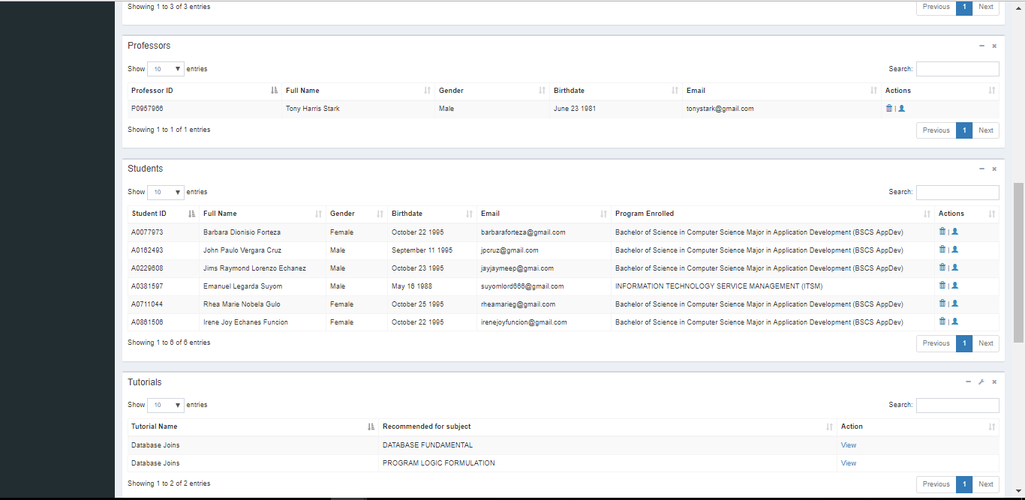

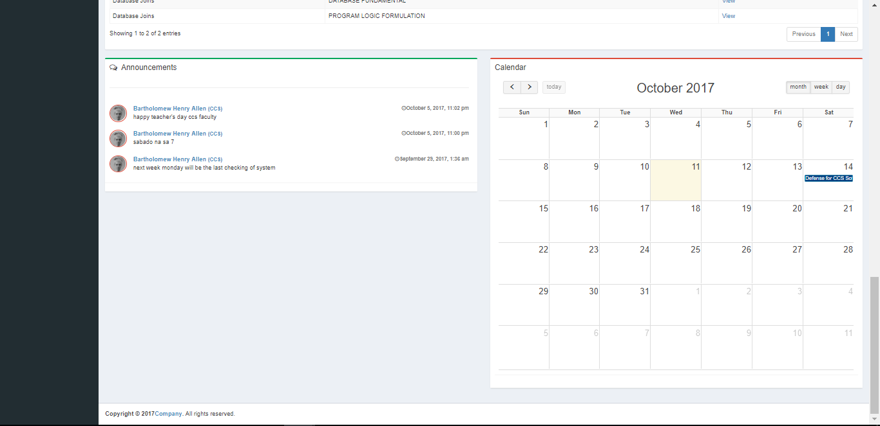

In department info you can see the department banner and logo, banner and logo can be customize

Next is the department head and the mission and vision of the department

Department also contains the program offered of that department , the professors and the students enrolled in that department.

Also there is a table that contains the the recommended tutorial for students

And at the very bottom you will see the announcement post by the department admins and the calendar of events of that specific department

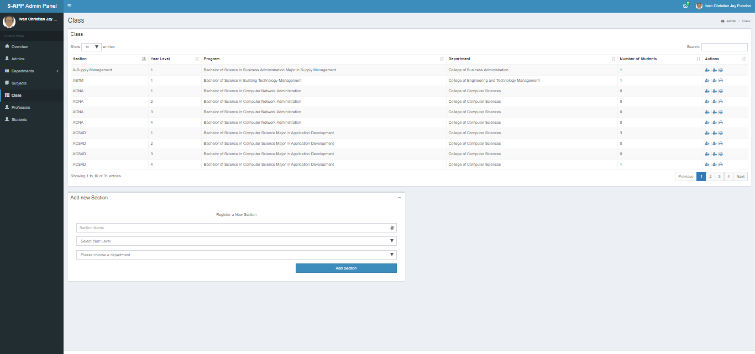

Class panel shows the class of every department

You can also add student to a class

Add prof to a class and print the master list of that

Add class to a department

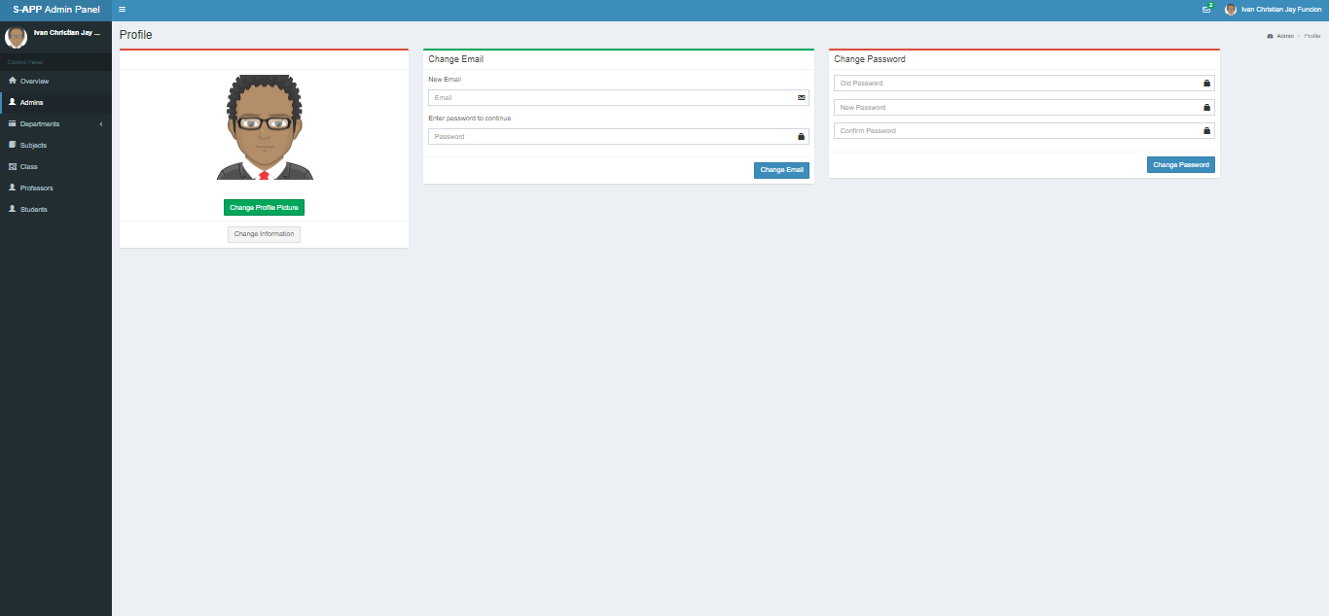

Change picture,email and password for the admin who is currently login

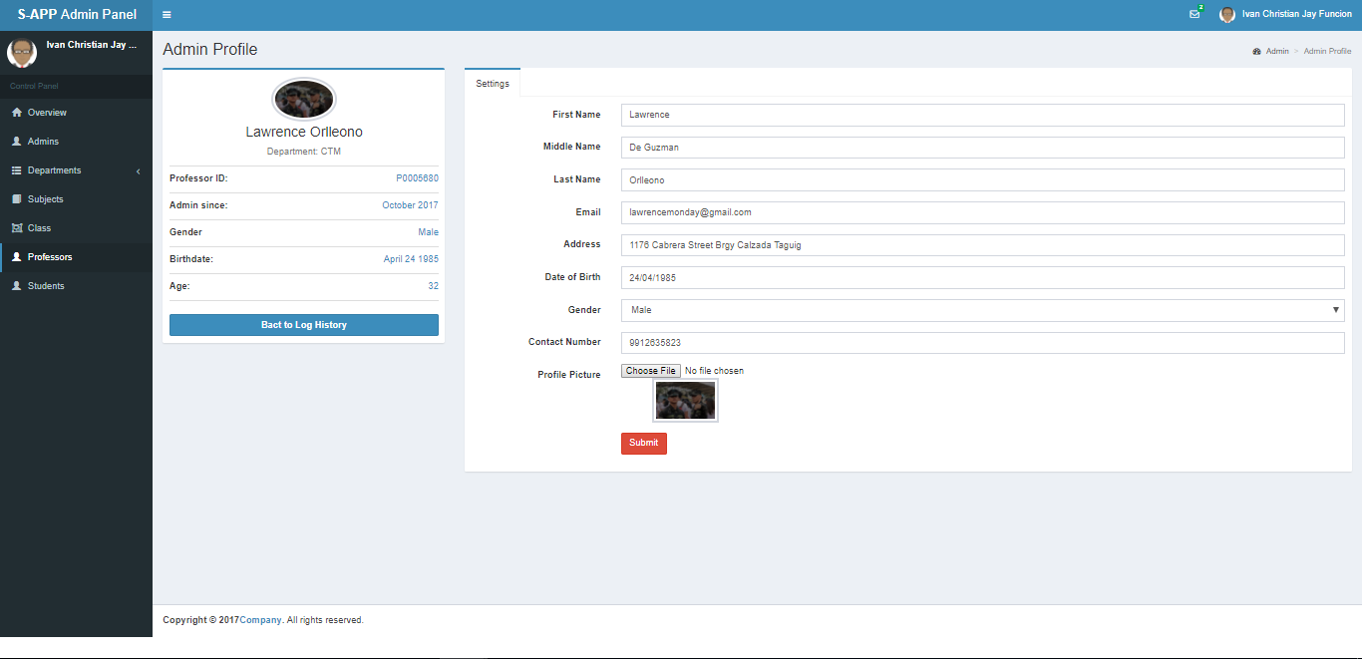

Shool admin and department admin can edit prof account

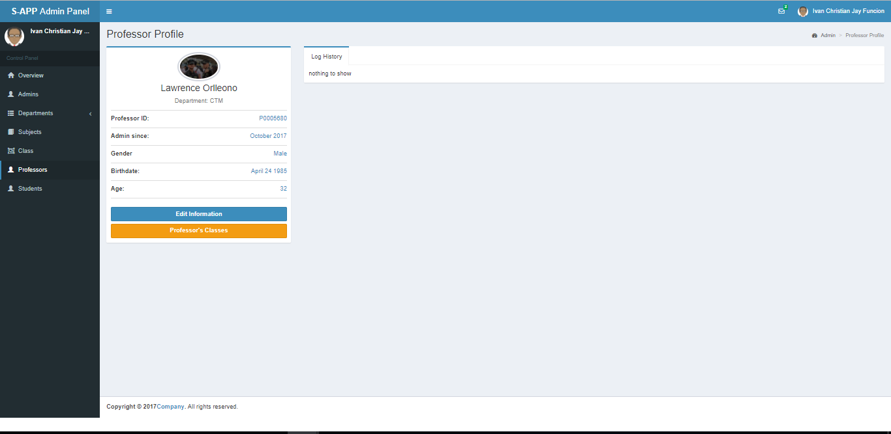

Professor’s log info

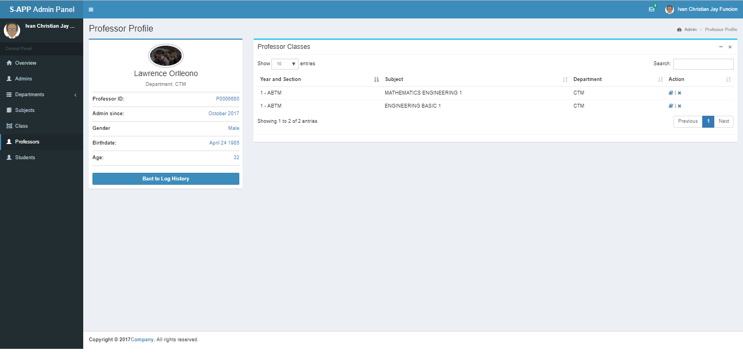

Professor’s classes… you can assign subject to a professor here

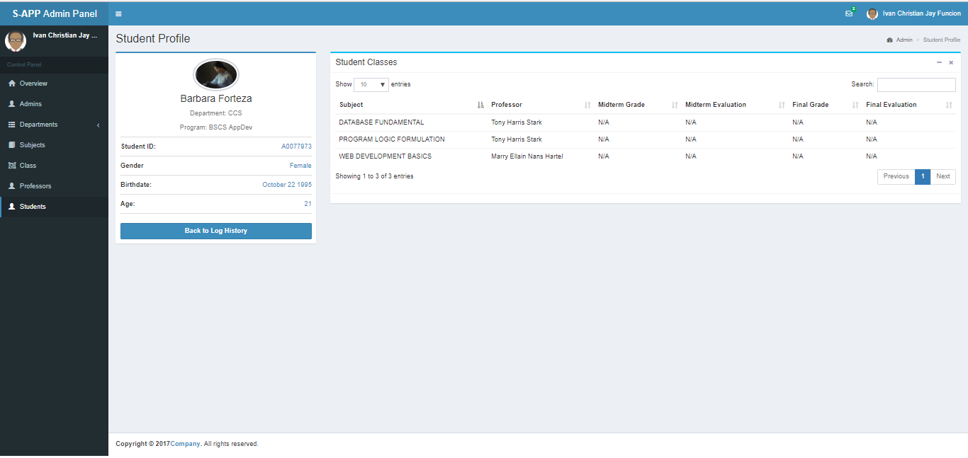

You can see the student performance in this page